1.MAP OPERATIONS
Code:
import java.util.*;
public class Main {
public static void main(String[] args) {
Scanner s=new Scanner(System.in);
Map<Integer,String> map=new HashMap <>();
map.put(1,"A");
map.put(2,"B");
map.put(3,"C");
map.put(4,"ASDFER");
map.put(5,"ERTY");
map.put(6,"HJKLF");
map.put(7,"MNBVCX");
map.putIfAbsent(6,"SDFAW");
map.putIfAbsent(8,"SDFAW");// adds only if the key is not present
System.out.println(map);
System.out.println("Size:"+map.size());
System.out.println("Value of Key 5:"+ map.get(5));
System.out.println(map.getOrDefault("0","HGD?FS"));
System.out.println("retriving the value key 3:"+map.containsKey(4));
System.out.println("retriving the value key 0:"+map.containsKey(0));
System.out.println("is b present:"+map.containsValue("B"));
System.out.println("is D present:"+map.containsValue("D"));
map.remove(5);
System.out.println(map);
map.replace(4,"D");
System.out.println(map);
map.replace(4,"D","L");
System.out.println(map);
System.out.println("Size:"+map.size());
System.out.println("Keyset:"+map.keySet());
System.out.println("VAlues"+map.values());
System.out.println("Entryset:"+map.entrySet());
System.out.println("Hashcode:"+map.hashCode());
map.clear();
System.out.println("ISEMPTY:"+map.isEmpty());
}
}
Output:
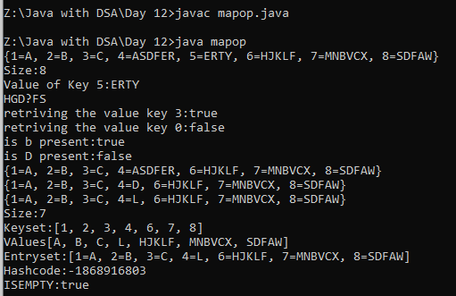
2.COUNT THE CHARACTERS IN AN ARRAY
Code:
import java.util.*;
public class count {
public static void main(String[] args) {
Scanner sc=new Scanner(System.in);
Map<Integer,Integer> map=new HashMap <>();
System.out.println("N:");
int n=sc.nextInt();
int []arr=new int[n];
System.out.println("Array elements:");
for(int i=0;i<n;i++){
arr[i]=sc.nextInt();
}
for(int i=0;i<arr.length;i++){
map.put(arr[i],map.getOrDefault(arr[i],0)+1);
}
for(Map.Entry<Integer,Integer> e:map.entrySet()){
System.out.println(e.getKey()+"="+e.getValue());
}
}
}
Output:
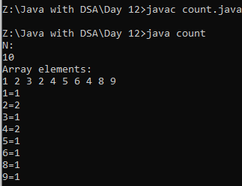
3.COUNT LETTERS IN A STRING
Code:
import java.util.*;
public class countletters {
public static void main(String[] args) {
Scanner sc=new Scanner(System.in);
Map<Character,Integer> map=new HashMap <>();
System.out.print("Str:");
String s=sc.next();
for(int i=0;i<s.length();i++){
char ch=s.charAt(i);
map.put(ch,map.getOrDefault(ch,0)+1);
}
for(Map.Entry<Character,Integer> e:map.entrySet()){
System.out.println(e.getKey()+"="+e.getValue());
}
}
}
Output:
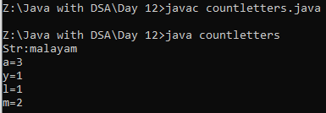
4.PRINT THE FIRST NON REPEATING CHARACTER
Code:
import java.util.*;
public class repeat {
public static void main(String[] args) {
Scanner s=new Scanner(System.in);
Map<Character,Integer> map=new HashMap <>();
System.out.print("Enter the String: ");
String str=s.nextLine();
for(int i=0;i<str.length();i++){
char ch=str.charAt(i);
map.put(ch,map.getOrDefault(ch,0)+1);
}
for(Map.Entry<Character,Integer> e:map.entrySet()){
if(e.getValue()==1){
System.out.print(e.getKey());
return;
}
}
System.out.print("There is no repeating character.....");
}}
Output:
